**Ghumshuda Evidence**

**Lost and found main sab milta ha!!!!**

A disk image will be given, you have to make a directory in your system and mount the image in it.

In this disk image you will find a file called lost+found (where the first hint will be used)

And you will get a .py file, upon running this file you will get an 64 bit encoded output decode it,

Now by this means that your system logs holds all the events happening then you have to search for logs....

In the logs you will find a password divided in 4 parts in 2 log files combining that you will get the password to open the zip file,

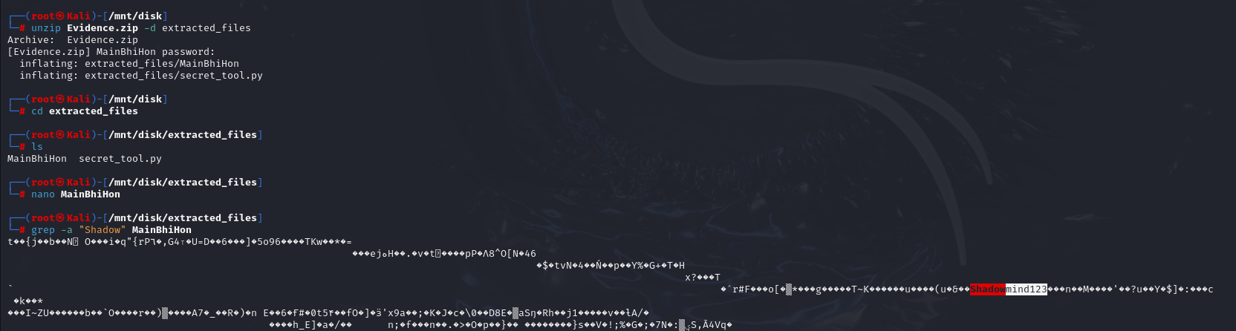

In this you will find 2 files of MainBhiHon and secret_tool, in MainBhiHon you have to search for the string “Shadow” as given hint in logs last part, and you will get the key to decrypt the flag in secret_tool.py. after this lastly decode the flag by base 64 and you will be good to go.

